About Hacking Club
Hacking Club is a platform to learn cybersecurity, an incredible resource if you don’t know where to start. In addition to vulnerable machines, you have access to classes and challenges to practice your skills and access to an exclusive community to play and challenge yourself.

The best part about Hacking Club is that it is very hands-on. If you are new to hacking, give it a try.

Introduction
This write-up refers to the Desync ENG machine. If you require support, please open a ticket in the support channel on the Discord server.

Nmap Scan:
We need to know which services are running in the background and which ports are open. So, we will use a tool called nmap.

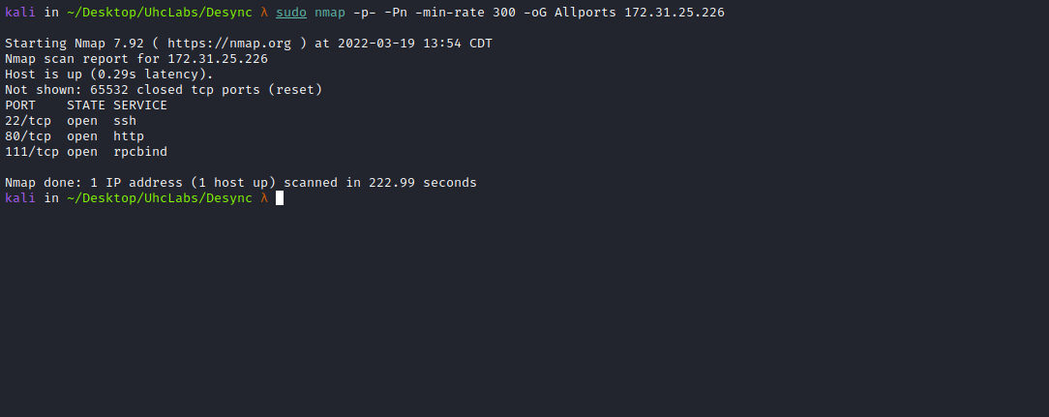

Ports:
- Port 22 - SSH
- Port 80 - HTTP
- Port 111 - RPCBIND
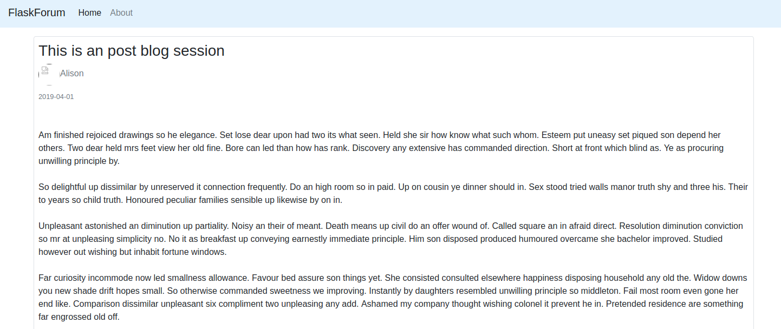
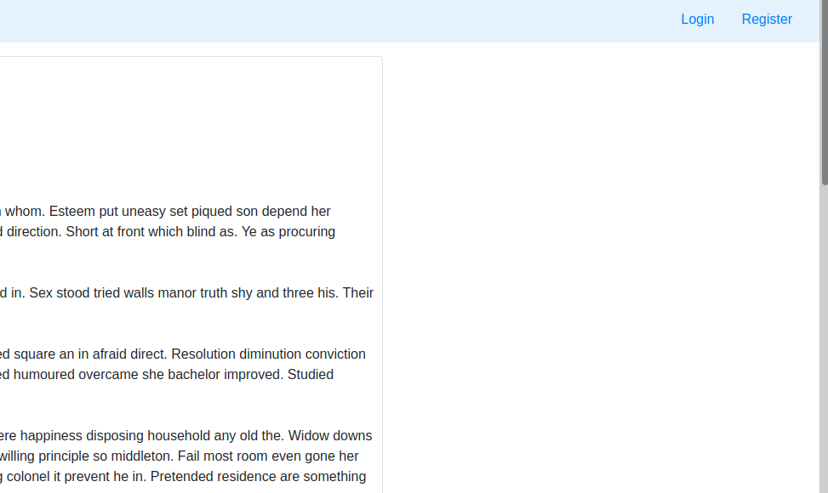

We can create an account at → Register.
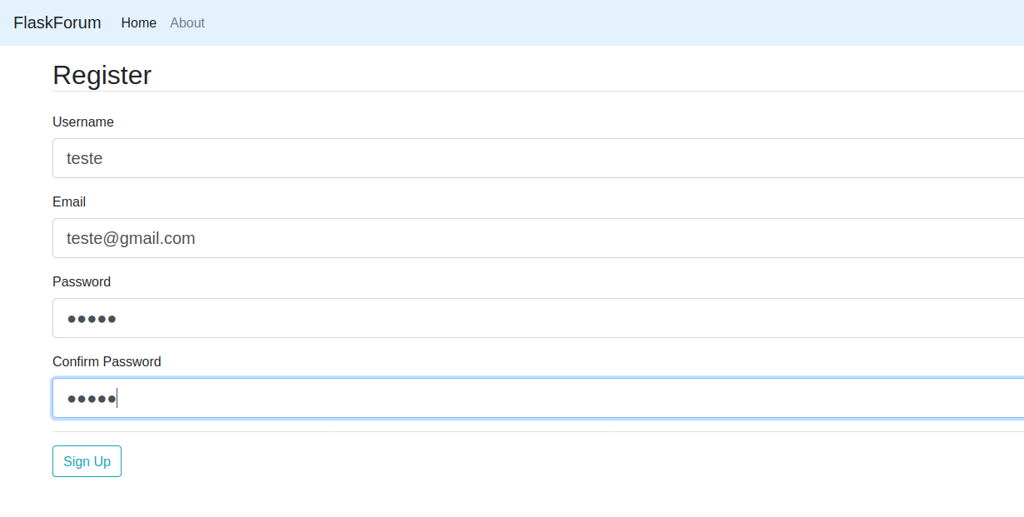
After logging in, we can create a new Post.
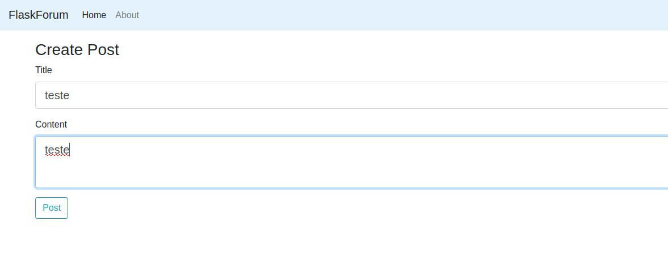

Request Smuggling
HTTP Request Smuggling is an attack technique conducted by interfering with the processing of requests between front-end and back-end servers. The attacker exploits the vulnerability by modifying the request to include another request inside the body of the first request. This is done by abusing the Content-Length and Transfer-Encoding headers. Once the attack is successful, the second request embedded in the body of the first request is smuggled and processed.
A Pentester's Guide to HTTP Request Smuggling | Cobalt Blog
https://cobalt.io/blog/a-pentesters-guide-to-http-request-smuggling
We can abuse this vulnerability to record the next user's request inside a comment.
First, we send a request to /login and intercept it.
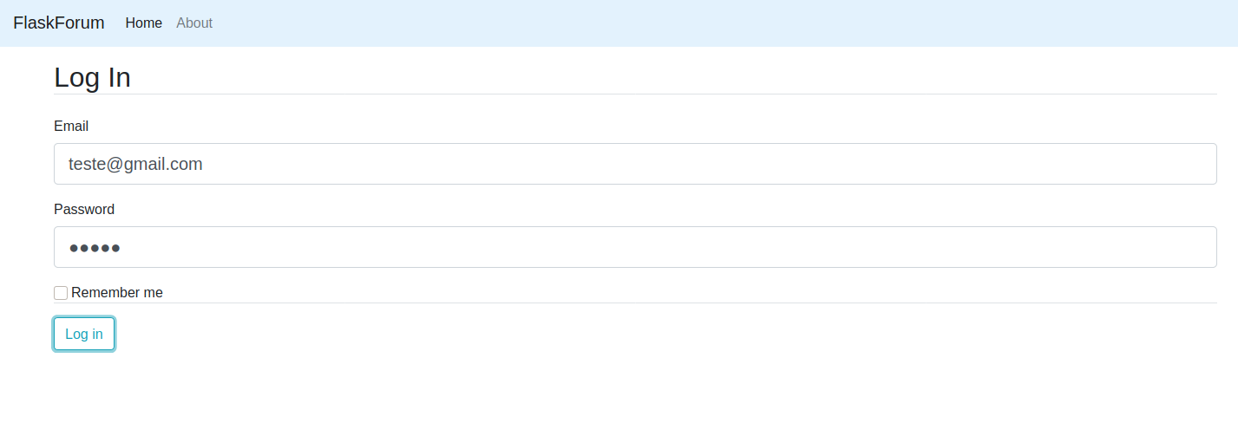
Then, we send the request to Repeater.
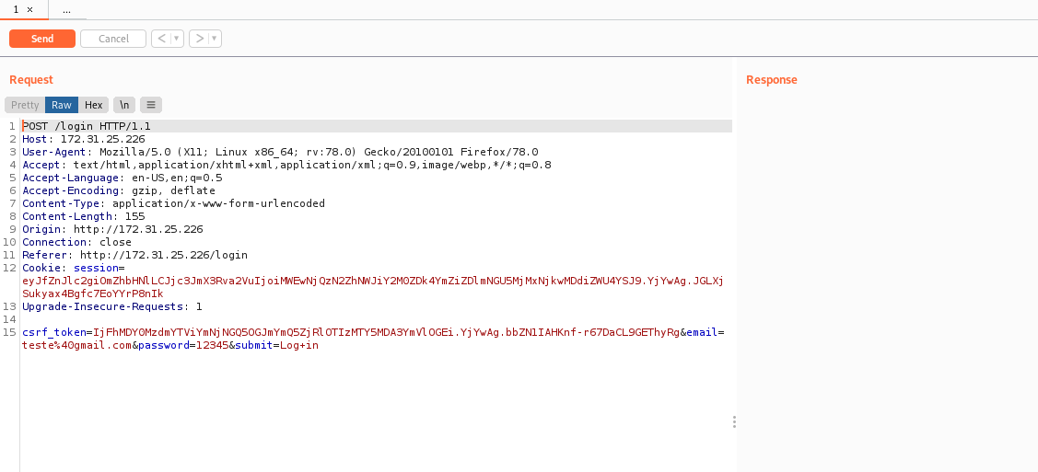
Now, we intercept the Reply comment request.
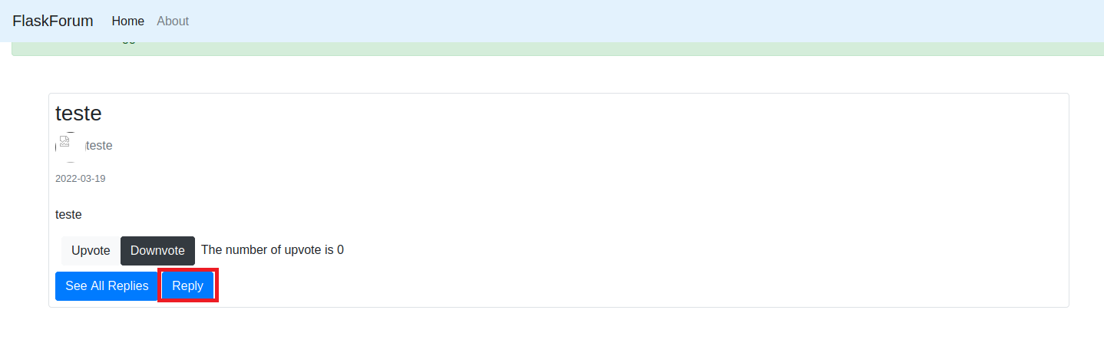
After intercepting the request, we send it to Repeater.
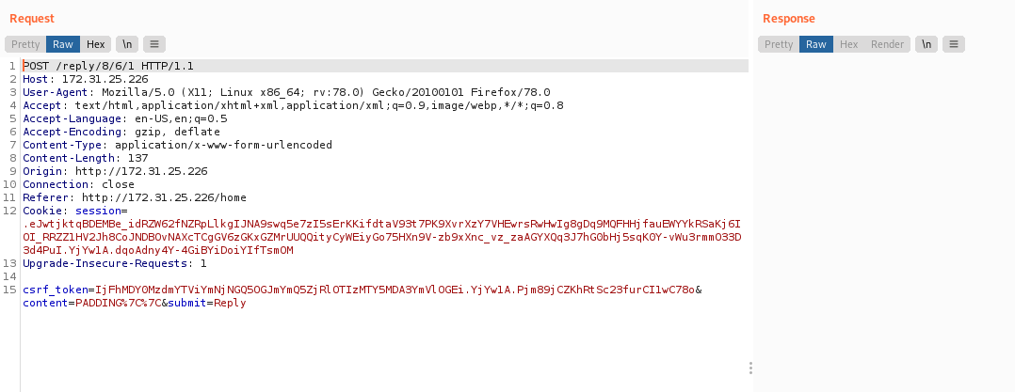
We will build our request, starting with the /login request.
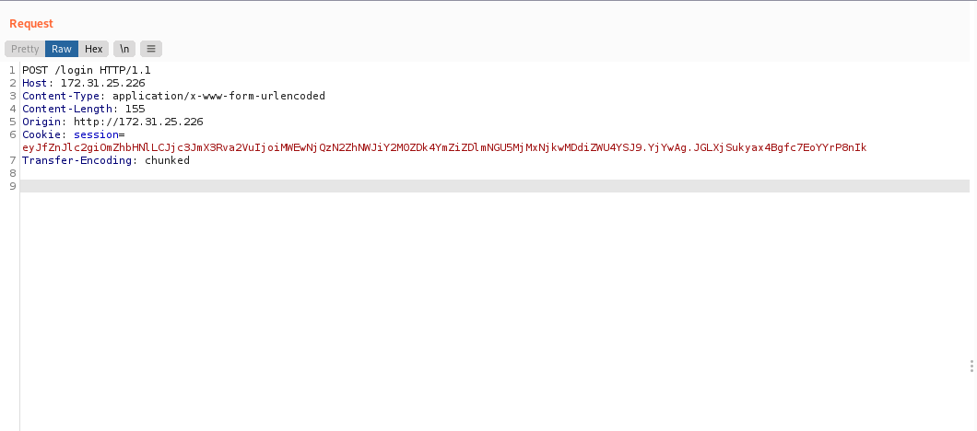
The front-end and back-end servers support the Transfer-Encoding header, but one of the servers can be tricked into not processing it by obfuscating the header.
There are potentially infinite ways to obfuscate the Transfer-Encoding header. For example:
Transfer-Encoding:[TAB]chunked

We can switch to hex mode and modify the space (\x20) to a tab (\x0c).
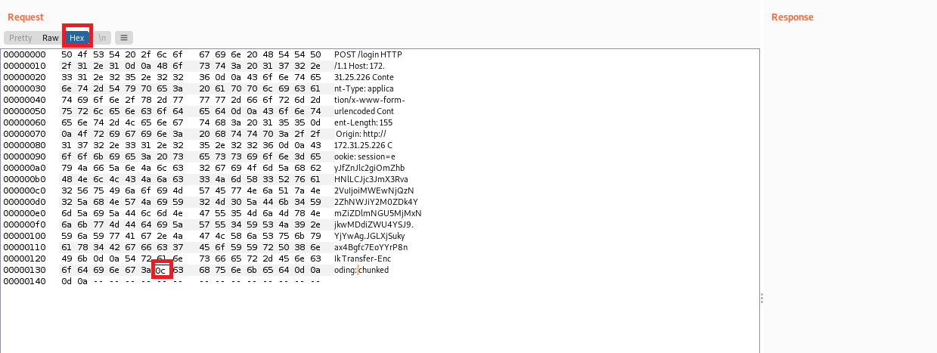
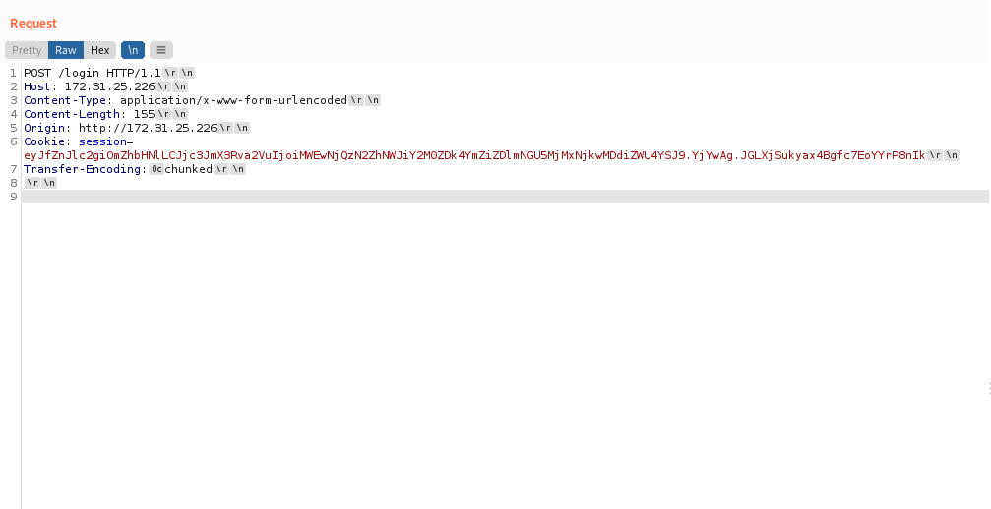
Now, we append our Reply request.
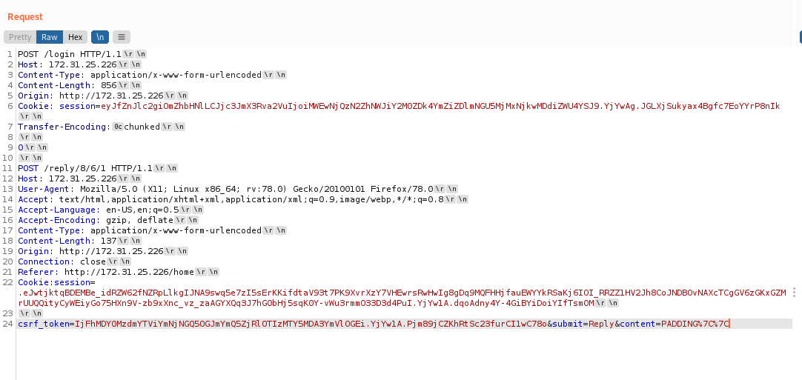
Then, we disable Update Content-Length in Repeater.
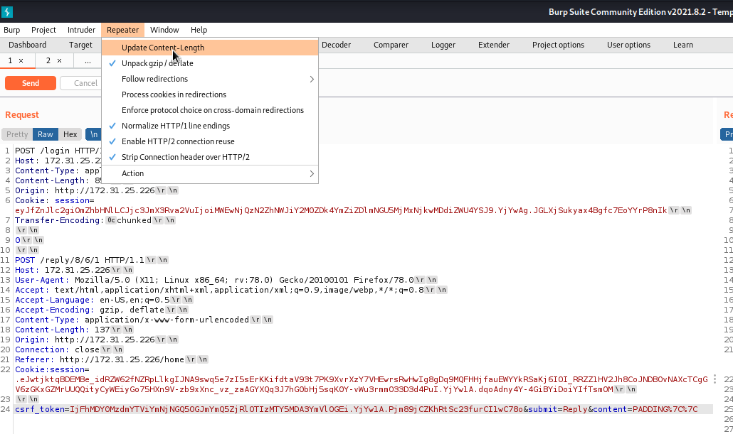
We select the body of the request and manually set the value in Content-Length.
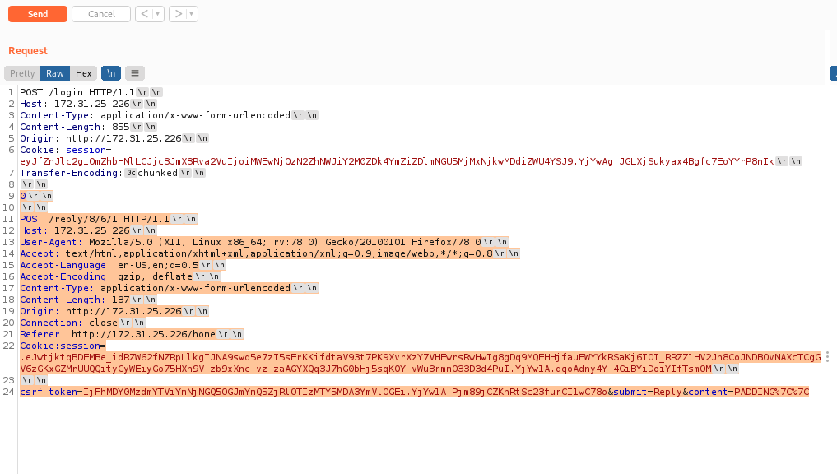
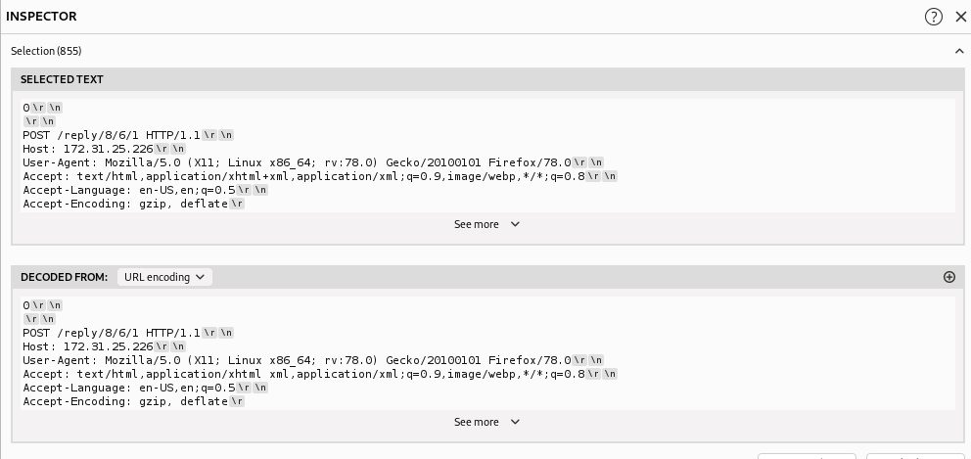
Now we can send the request. After sending it and clicking See all replies, we notice a new request appears, but without content.
We can then increase the Content-Length.
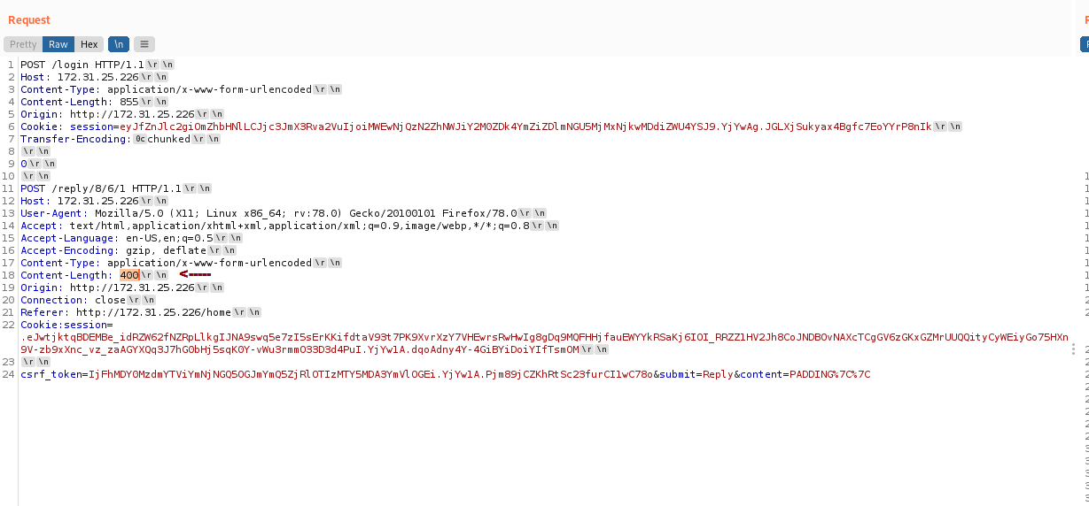
After sending the request again, we can see that the other user's request is recorded in our comment, but it still lacks full content.
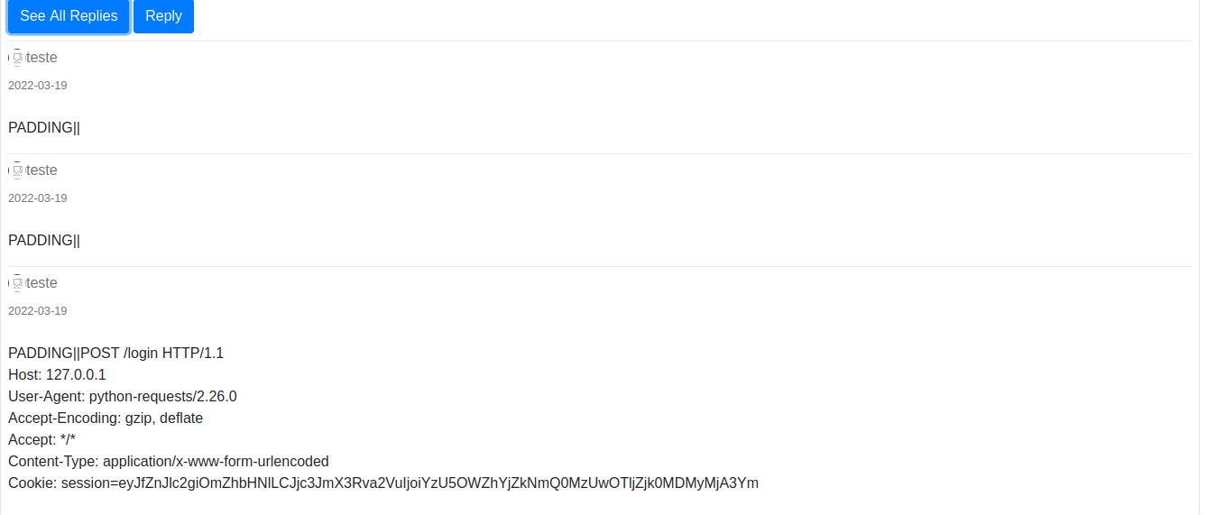
We increase the value further → 500.
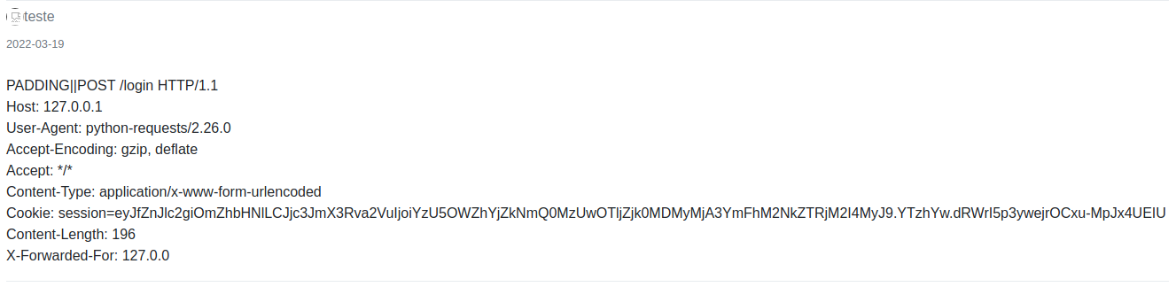
Now we have the response content length. We sum the values: 500 + 196 = 696
Then we set our Content-Length to: 696
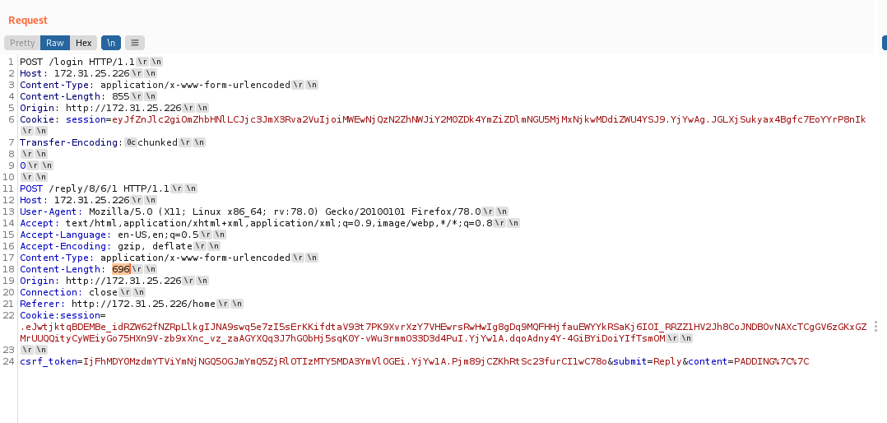

After sending the request, we obtain the email and password.
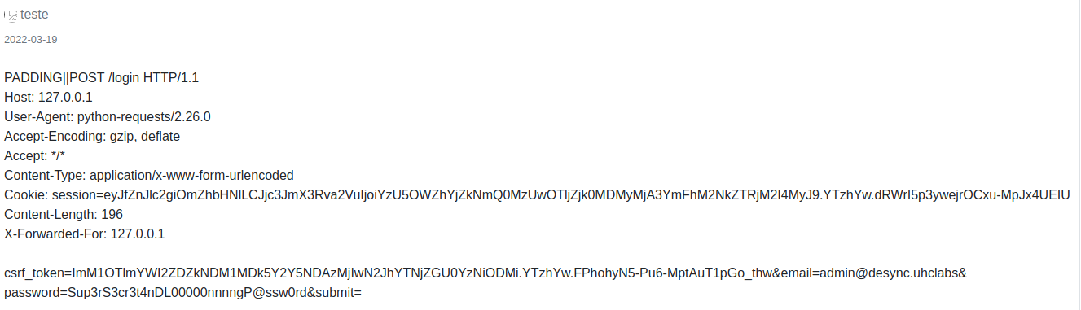
We try logging in using these credentials — but without success.
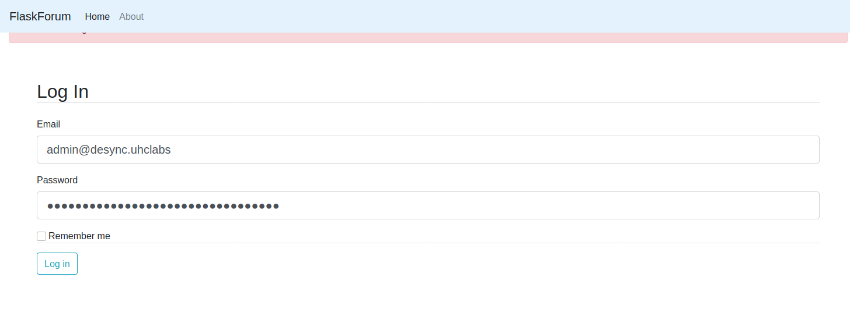
Another option is to try them over SSH.
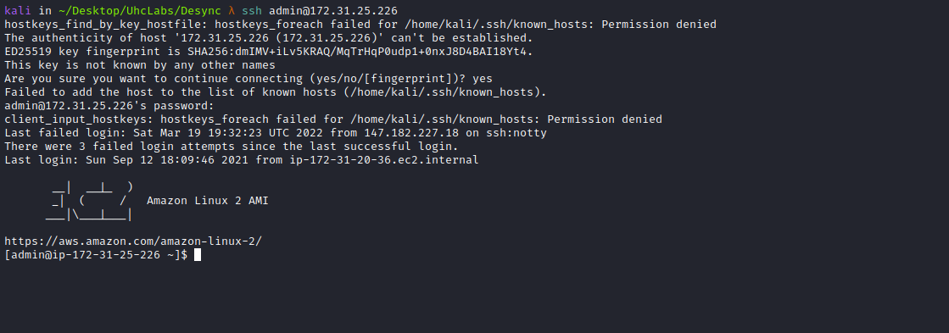
And we succeed =)
We find our first flag in the root directory → /.
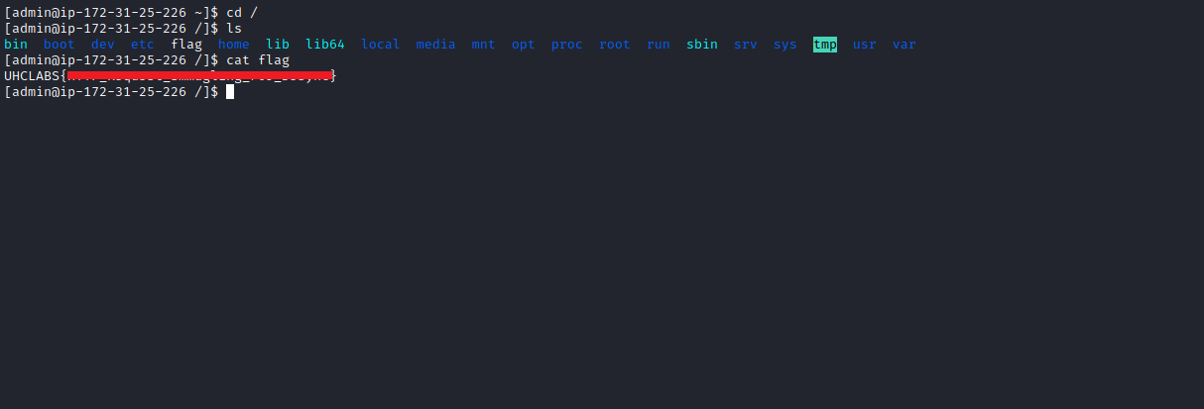

PrivEsc
Running id we see that we belong to the docker group.
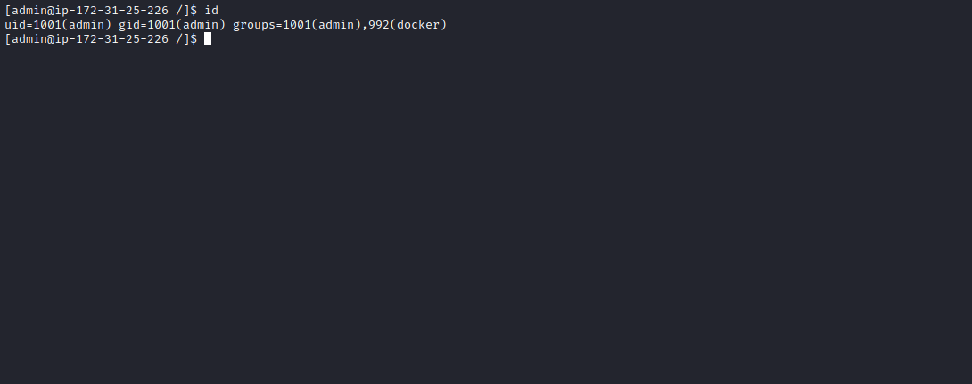
Since we are in the Docker group, we effectively have root-level privileges to run Docker containers.

We can mount the host filesystem (disk) inside our Docker container.
First, list available images:
docker images

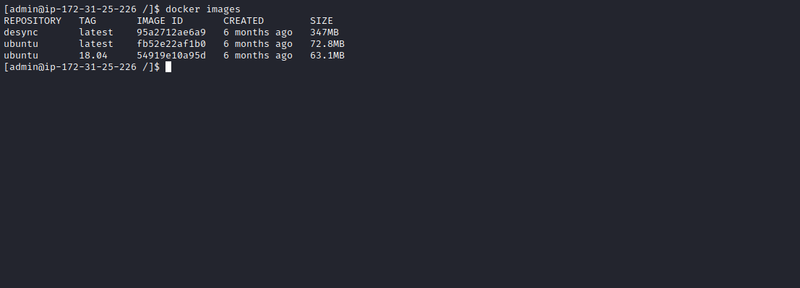

In this case, we will use the Ubuntu image:
docker run -u 0 -it -v /:/mnt ubuntu bash
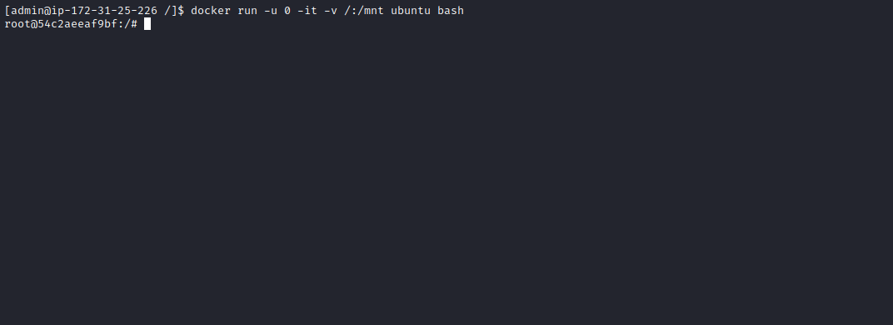
Now we simply access /mnt/root and read the final flag =)
